The Gathering of the People of God

The Greeting

The Lord is full of compassion and mercy,
slow to anger and of great kindness. Psalm 103

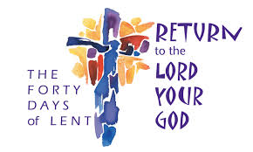
The Lord be with you
All and also with you.

Welcome

Opening Hymn
Please STAND if able

Comfortable words
Please SIT or KNEEL

Hear the words of comfort our Saviour Christ says to all who truly turn to him:

Come to me, all who labour and are heavy laden,
and I will give you rest. Matthew 11.28

God so loved the world that he gave his only-begotten Son,
that whoever believes in him should not perish but have eternal life. John 3.16

Hear what Saint Paul says:
This saying is true, and worthy of full acceptance, that Christ Jesus came into the world to save sinners. 1 Timothy 1.15

Hear what Saint John says:
If anyone sins, we have an advocate with the Father,
Jesus Christ the righteous;
and he is the propitiation for our sins. 1 John 2.1, 2

All Almighty God,
to whom all hearts are open,
all desires known,
and from whom no secrets are hidden:
cleanse the thoughts of our hearts
by the inspiration of your Holy Spirit,
that we may perfectly love you,
and worthily magnify your holy name;
through Christ our Lord.
Amen.

Prayers of Penitence

Our Lord Jesus Christ said: The first commandment is this: ‘Hear, O Israel, the Lord our God is the only Lord.
You shall love the Lord your God with all your heart,
with all your soul, with all your mind, and with all your strength.’ The second is this: ‘Love your neighbour as yourself.’
There is no other commandment greater than these.
On these two commandments hang all the law and the prophets.

All Amen. Lord, have mercy.

Compassion and forgiveness belong to the Lord our God,
though we have rebelled against him.
Let us then renounce our wilfulness and ask his mercy
by confessing our sins in penitence and faith.

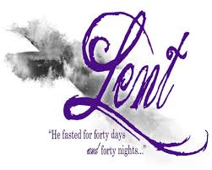
All Father eternal, giver of light and grace,
we have sinned against you and against our neighbour,
in what we have thought,
in what we have said and done,
through ignorance, through weakness,
through our own deliberate fault.
We have wounded your love
and marred your image in us.
We are sorry and ashamed,
and repent of all our sins.
For the sake of your Son Jesus Christ,
who died for us,
forgive us all that is past;
and lead us out from darkness
to walk as children of light.
Amen.

Absolution

May almighty God,
who sent his Son into the world to save sinners,
bring you his pardon and peace, now and for ever.
All Amen.

The Collect
The Minister introduces a period of quiet prayer
followed by the Church’s prayer for the week,
which can be found in the weekly Bulletin sheet.

The Liturgy of the Word

Bible Readings

Please SIT. At the end of each the reader may say

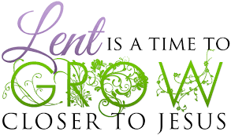
This is the word of the Lord.
Thanks be to God.

Gospel Hymn
Please STAND if able

The Holy Gospel
Please remain standing,
when the Gospel is announced and the reader says

Praise to you, O Christ, King of eternal glory.
The Lord is a great God,
O that today you would listen to His voice.
Harden not your hearts
All Praise to you, O Christ, King of eternal glory

At the end

This is the Gospel of the Lord.
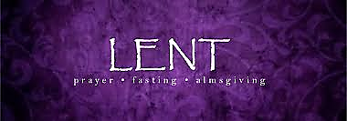
All Praise to you, O Christ.

Sermon

Please SIT for the sermon

The Creed

Please STAND if able as we declare the faith we share.
Let us affirm our faith in Jesus Christ the Son of God.
All Though he was divine,
he did not cling to equality with God,
but made himself nothing.
Taking the form of a slave,
he was born in human likeness.
He humbled himself
and was obedient to death,
even the death of the cross.
Therefore God has raised him on high,
and given him the name above every name:
that at the name of Jesus every knee should bow,
and every voice proclaim that Jesus Christ is Lord,
to the glory of God the Father.
Amen.
cf Philippians 2.6-11

Prayers of Intercession

Please SIT or KNEEL as we pray
Lord of compassion (or) Lord hear us
In your mercy hear our prayer. Lord graciously hear us

And at the end

Merciful Father,
All accept these prayers
for the sake of your Son,
our Saviour Jesus Christ.
Amen.

The Liturgy of the Sacrament

The Peace
Since we are justified by faith,
we have peace with God through our Lord Jesus Christ,
who has given us access to His grace.
The peace of the Lord be always with you
All And also with you

Let us offer each other a sign of peace.

We exchange a sign of peace, a hand shake, a hug or a kiss

Offertory Hymn

Please STAND, if able, as we sing while the bread
and wine are presented and the collection taken.

Preparation of the Table

Prayers may be said as the gifts,
bread, wine and collection are presented.

God of mercy and compassion,
your Word calls us home
to faith and love.
Accept all we offer you this day;
in the name of Jesus Christ,
the Lord.
All Amen.

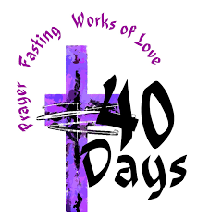
Eucharistic Prayer B

The Lord is here.
All His Spirit is with us.

Lift up your hearts.
All We lift them to the Lord.

Let us give thanks to the Lord our God.
All It is right to give thanks and praise.

It is indeed right and good
to give you thanks and praise,
almighty God and everlasting Father,
through Jesus Christ your Son.
For in these forty days
you lead us into the desert of repentance
that through a pilgrimage of prayer and discipline
we may grow in grace
and learn to be your people once again.
Through fasting, prayer and acts of service
you bring us back to your generous heart.
Through study of your holy word
you open our eyes to your presence in the world
and free our hands to welcome others
into the radiant splendour of your love.
As we prepare to celebrate the Easter feast
with joyful hearts and minds
we bless you for your mercy
and join with saints and angels
for ever praising you and singing:

Holy, holy, holy Lord,
God of power and might,
heaven and earth are full of your glory.
Hosanna in the highest.

Blessed is he who comes in the name of the Lord.
Hosanna in the highest.

Lord, you are holy indeed, the source of all holiness;
grant that by the power of your Holy Spirit,
and according to your holy will,
these gifts of bread and wine
may be to us the body and blood of our Lord Jesus Christ;

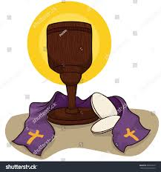
who, in the same night that he was betrayed,
took bread and gave you thanks;
he broke it and gave it to his disciples, saying:
Take, eat; this is my body which is given for you;
do this in remembrance of me.

In the same way, after supper
he took the cup and gave you thanks;
he gave it to them, saying:
Drink this, all of you;
this is my blood of the new covenant,
which is shed for you and for many for the forgiveness of sins.
Do this, as often as you drink it,
in remembrance of me.

Praise to you, Lord Jesus:
Dying you destroyed our death,
rising you restored our life:
Lord Jesus, come in glory.

And so, Father, calling to mind his death on the cross,
his perfect sacrifice made once for the sins of the whole world;
rejoicing in his mighty resurrection and glorious ascension,
and looking for his coming in glory,
we celebrate this memorial of our redemption.

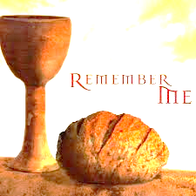
As we offer you this our sacrifice of praise and thanksgiving,
we bring before you this bread and this cup
and we thank you for counting us worthy
to stand in your presence and serve you.

Send the Holy Spirit on your people
and gather into one in your kingdom
all who share this one bread and one cup,
so that we, in the company of [N and] all the saints,
may praise and glorify you for ever,
through Jesus Christ our Lord;
by whom, and with whom, and in whom,
in the unity of the Holy Spirit,
all honour and glory be yours, almighty Father,
for ever and ever.
All Amen.

The Lord’s Prayer

Let us pray with confidence as our Saviour has taught us

All Our Father, who art in heaven,
hallowed be thy name;
thy kingdom come;
thy will be done;
on earth as it is in heaven.
Give us this day our daily bread.
And forgive us our trespasses,
as we forgive those who trespass against us.
And lead us not into temptation;
but deliver us from evil.
For thine is the kingdom,
the power and the glory,
for ever and ever. Amen
Breaking of the Bread

We break this bread
to share in the body of Christ.
All Though we are many, we are one body,
because we all share in one bread.

All Jesus, Lamb of God,
have mercy on us.

Jesus, bearer of our sins,
have mercy on us.

Jesus, redeemer of the world,
grant us peace.

Sharing of Communion

Draw near with faith.
Receive the body of our Lord Jesus Christ
which he gave for you,
and his blood which he shed for you.
Eat and drink in remembrance that he died for you,
and feed on him in your hearts
by faith with thanksgiving.

The Minister and people receive communion or a blessing.
All are welcome.
If you would rather receive a blessing,
please bring your service booklet to the Lord’s Table with you.
During the distribution hymns may be sung.

Prayer after communion
Silence is kept, the Minister leads us in prayer

All Generous God,
you have fed us at your heavenly table.
Set us on fire with your Spirit
that when Christ comes again
we may shine like lights before his face,
who with you and the Spirit lives forever.
Amen

Notices
Please SIT as notices are given, banns of marriage declared.
We hear from our young people what they have been up to.

Hymn
We STAND, if able, for our final hymn

Blessing
Please STAND as the Minister asks God’s blessing for us all:

Christ give you grace to grow in holiness,
to deny yourselves, take up your cross, and follow him;
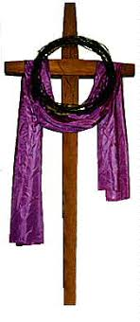
and the blessing of God almighty
the Father the Son and the Holy Spirit
be with you all, evermore.
All Amen

Go in peace to love and serve the Lord
All in the name of Christ Amen.

The Minister moves to the door to greet everyone
Do please stay and share refreshments

Thank you for joining us for this service today.

Please find much more information about our church, services, updates and events on our church website

www.hamptoninardenchurch.org.uk

